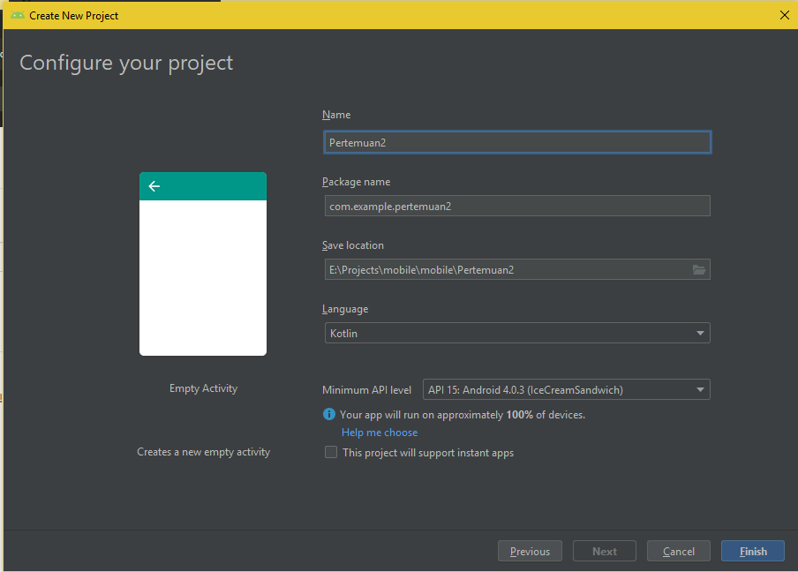

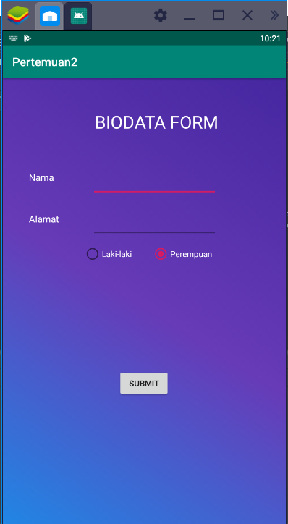 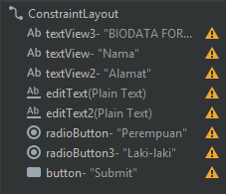

Gambar background gradient berada di dalam folder drawable

|  |
| --- |
| <?xml version="1.0" encoding="utf-8"?>  <selector xmlns:android="http://schemas.android.com/apk/res/android">  <item>  <shape>  <gradient  android:startColor="#1e88e5"  android:centerColor="#673ab7"  android:endColor="#4527a0"  android:angle="45">  </gradient>  </shape>  </item>  </selector> |

Kode yang ada di main_activity

|  |
| --- |
| <?xml version="1.0" encoding="utf-8"?>  <androidx.constraintlayout.widget.ConstraintLayout xmlns:android="http://schemas.android.com/apk/res/android"  xmlns:app="http://schemas.android.com/apk/res-auto"  xmlns:tools="http://schemas.android.com/tools"  android:orientation="horizontal"  android:background="@drawable/bggraident"  android:layout_width="match_parent"  android:layout_height="match_parent"  tools:context=".MainActivity">  <TextView  android:id="@+id/textView3"  android:layout_width="wrap_content"  android:layout_height="wrap_content"  android:text="BIODATA FORM"  android:textColor="#FFFFFF"  android:textSize="30dp"  app:layout_constraintBottom_toBottomOf="parent"  app:layout_constraintEnd_toEndOf="parent"  app:layout_constraintHorizontal_bias="0.576"  app:layout_constraintStart_toStartOf="parent"  app:layout_constraintTop_toTopOf="parent"  app:layout_constraintVertical_bias="0.073" />  <TextView  android:id="@+id/textView"  android:layout_width="wrap_content"  android:layout_height="wrap_content"  android:layout_marginTop="156dp"  android:text="Nama"  android:textColor="#FFFF"  android:textSize="16dp"  app:layout_constraintBottom_toBottomOf="parent"  app:layout_constraintEnd_toEndOf="parent"  app:layout_constraintHorizontal_bias="0.1"  app:layout_constraintStart_toStartOf="parent"  app:layout_constraintTop_toTopOf="parent"  app:layout_constraintVertical_bias="0.001" />  <TextView  android:id="@+id/textView2"  android:layout_width="wrap_content"  android:layout_height="wrap_content"  android:layout_marginTop="156dp"  android:text="Alamat"  android:textColor="#FFFF"  android:textSize="16dp"  app:layout_constraintBottom_toBottomOf="parent"  app:layout_constraintEnd_toEndOf="parent"  app:layout_constraintHorizontal_bias="0.103"  app:layout_constraintStart_toStartOf="parent"  app:layout_constraintTop_toTopOf="parent"  app:layout_constraintVertical_bias="0.12" />  <EditText  android:id="@+id/editText"  android:layout_width="wrap_content"  android:layout_height="wrap_content"  android:ems="10"  android:inputType="textPersonName"  android:text=""  android:textColor="#FFFF"  app:layout_constraintBottom_toBottomOf="parent"  app:layout_constraintEnd_toEndOf="parent"  app:layout_constraintHorizontal_bias="0.565"  app:layout_constraintStart_toStartOf="parent"  app:layout_constraintTop_toTopOf="parent"  app:layout_constraintVertical_bias="0.212" />  <EditText  android:id="@+id/editText2"  android:layout_width="wrap_content"  android:layout_height="wrap_content"  android:ems="10"  android:inputType="textPersonName"  android:text=""  android:textColor="#FFFF"  app:layout_constraintBottom_toBottomOf="parent"  app:layout_constraintEnd_toEndOf="parent"  app:layout_constraintHorizontal_bias="0.565"  app:layout_constraintStart_toStartOf="parent"  app:layout_constraintTop_toTopOf="parent"  app:layout_constraintVertical_bias="0.309" />  <RadioButton  android:id="@+id/radioButton"  android:layout_width="wrap_content"  android:layout_height="wrap_content"  android:text="Perempuan"  android:textColor="#FFFF"  app:layout_constraintBottom_toBottomOf="parent"  app:layout_constraintEnd_toEndOf="parent"  app:layout_constraintHorizontal_bias="0.669"  app:layout_constraintStart_toStartOf="parent"  app:layout_constraintTop_toTopOf="parent"  app:layout_constraintVertical_bias="0.38" />  <RadioButton  android:id="@+id/radioButton3"  android:layout_width="wrap_content"  android:layout_height="wrap_content"  android:text="Laki-laki"  android:textColor="#FFFF"  app:layout_constraintBottom_toBottomOf="parent"  app:layout_constraintEnd_toEndOf="parent"  app:layout_constraintHorizontal_bias="0.342"  app:layout_constraintStart_toStartOf="parent"  app:layout_constraintTop_toTopOf="parent"  app:layout_constraintVertical_bias="0.38" />  <Button  android:id="@+id/button"  android:layout_width="wrap_content"  android:layout_height="wrap_content"  android:text="Submit"  app:layout_constraintBottom_toBottomOf="parent"  app:layout_constraintEnd_toStartOf="parent"  app:layout_constraintHorizontal_bias="0.501"  app:layout_constraintStart_toEndOf="parent"  app:layout_constraintTop_toTopOf="parent"  app:layout_constraintVertical_bias="0.68" />  </androidx.constraintlayout.widget.ConstraintLayout> |